Funding Guidelines

Qualifying members of the Charitable Healthcare Network (CHN) are invited to submit an application to receive Uninsured Care Funds (UCF) to provide health care services to uninsured and under-insured Ohioans. These funds will come to CHN through the Ohio Department of Health and are meant to help defray the costs incurred by providing direct patient care.

Use of Funds

These funds may be used for uncompensated services to uninsured and underinsured Ohioans. Services may include any of the following: primary medical care, vision care, dental care, referrals and specialty care, mental health treatment and counseling, prescription assistance, laboratory and diagnostic services. In addition, funds may be used to support client copay and deductible costs.

Eligibility

In order to be eligible for funding, the applying organization must meet the following requirements:

- Provide direct patient health care services for uninsured and/or under-insured Ohioians
- Not bill patients for healthcare services
- Not refuse to see patients because of inability to pay for services
- Be a Member in Good Standing with Charitable Healthcare Network.

Quarterly Payments

Payments to clinics are dependent on the clinic remaining a member in good standing. Requirements for a Member in Good Standing are:

- Membership dues are paid on time
- Annual Survey and other reporting data are complete and submitted on time
- A representative of the clinic attends the Annual Business Meeting

Generally, quarterly payments will be disbursed to clinics no later than the first full week of:

- TBD (shooting for end of January)
- March
- June
- September

Reporting

If you are awarded a grant, you will be responsible for submitting a report detailing information on services provided and patients served as well as a descriptive narrative of how the money was spent. These reports will be due on the following dates:

January 8, 2020: Q1 Report (July 1, 2019 - September 30, 2019)
January 17, 2020: Q2 Report (October 1, 2019 - December 31, 2019)
April 17, 2020: Q3 Report (January 1, 2020 - March 31, 2020)
July 17, 2020: Q4 Report (April 1, 2020 - June 30, 2020)

Please mark your calendars now with the report due dates!

If you submit an incomplete report or a report on the incorrect version of the reporting form, it will not be accepted and you will not receive funding for that reporting period.

If you do not submit a report by the deadline you will not receive funding for that reporting period.

You are required to report any changes in key staff, clinic site locations and/or changes in the services you are providing for the uninsured/under-insured when those changes occur.

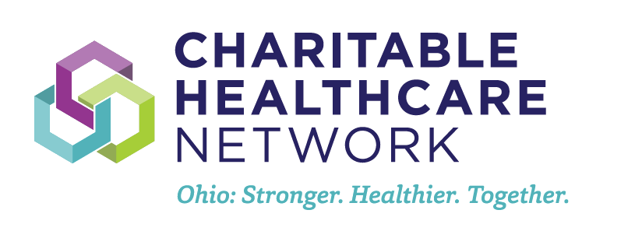

Application

Organizational Information

Organization Name: ______________________________________________________

Organization Mailing Address: ______________________________________________

Executive Director

Name: _________________________________________________________________

Phone: _________________________________________________________________

Email: _________________________________________________________________

Grant Manager (if different than Executive Director)
Who we can contact for reporting clarification

Name: _________________________________________________________________

Phone: _________________________________________________________________

Email: _________________________________________________________________

Narrative

Please provide a narrative outlining how these funds will help you to provide healthcare services to the population you serve. You may provide an overview of the impact of the funding and services and/or a specific example of how they have impacted services in the past. Please indicate the anticipated increase in your services and/or the number of individuals being served with the increase in funding. (3,000 word max)

